Panbio™ COVID-19 Antigen Rapid Test - How to test yourself
This handout explains how to use a COVID-19 rapid test kit on yourself. You may also be given more instructions by the person who gives you the test kit. Please read the kit instructions carefully before using it.
Note: If you have ANY symptoms or if you have been exposed to someone with COVID-19, do NOT use this test kit, and instead seek testing with a laboratory test at an assessment centre or community lab.

Materials you need to check in your kit before you test yourself
Your test kit will include the following materials:
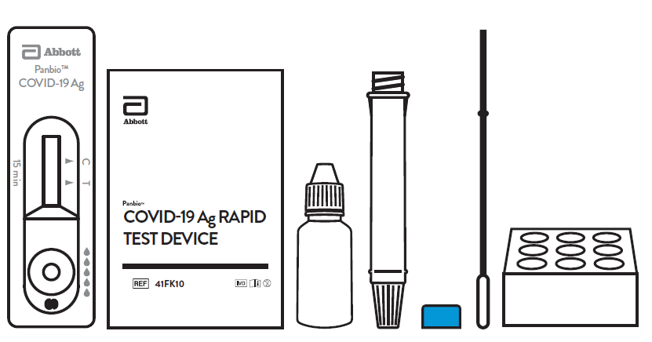
- Panbio™ liquid buffer bottle
- 25 Test tubes that have soft, flexible sides
- 25 Packaged test cartridges
- 25 Packaged swabs
- 25 Blue caps for test tubes
- Tube rack or holder

Make sure your kit has all the materials listed above and that none of the materials are expired or damaged. If any materials are damaged, get a new kit.
To avoid damage to the items in the kit, store it at room temperature (not in the fridge or freezer) and away from direct sunlight.
You should also have the following items close by:
- Facial tissues
- Handwashing sink
- Garbage bag and bag holder (e.g. garbage can)

Getting ready for testing
Find a clean area to do the test.
- The area must be free of any clutter, food, or drink.
- The surface of your test area should be flat and easy to clean if you spill something.
- Avoid slippery or absorbent surfaces like carpets or fabrics on furniture near your test area.
While you are doing the test, do not:
- Eat or drink
- Smoke or vape
- Put in contact lenses
- Put on make-up
- Touch your eyes or mouth in any way
The liquid in the buffer bottle can irritate (bother) your eyes and skin. The liquid is toxic (dangerous) if swallowed. Try not to splash the liquid while doing the test. If you spill liquid, clean it up well with a disinfectant.
Although the small amount of liquid used for the test is not likely to cause harm, follow the safety measures below:
- If the liquid touches your skin, wash your skin with plenty of water for at least 15 minutes.
- If the liquid touches your eyes, immediately flush your eyes with plenty of water for at least 15 minutes. Contact your health care provider or the Ontario Poison Centre (1-800-268-9017, or 416-813-5900) for assistance.
- If you swallow the liquid by mistake, immediately rinse your mouth with water. Contact your health provider or the Ontario Poison Centre for assistance.
How to test yourself using the rapid test
After checking your kit for damage, you can go ahead and use the kit to test yourself. The steps on how to test yourself are described here.
1. Blow your nose and wash your hands
- Before you start, gently blow your nose into a tissue.
- Wash your hands with warm, soapy water for 20 seconds. If soap and water are unavailable, use hand sanitizer.
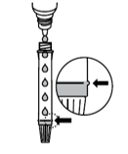
2. Fill the test tube with liquid
- Uncap the liquid buffer bottle and fill an empty test tube up to the ridged line (around 10 drops).
  - If you use too little or too much liquid, you may get an incorrect test result.
  - Do not touch the liquid itself, the bottle dispenser tip, or the test tube opening with your hands.
  - Use only the liquid provided in the kit. Do not replace the liquid with any other liquids (e.g. tap water) otherwise the results may not be correct.
- Put the cap tightly on the liquid buffer bottle. Place the bottle away from the testing area so that you do not contaminate (get any other materials in) the rest of the liquid in the bottle.
3. Open the test cartridge and nasal swab
- Peel open a new sealed test cartridge.
- Remove the cartridge from the package and place it on a clean and flat surface. Do not touch the round well or the rectangular result window with the visible test strip with your hands.
- Peel open a new sealed swab wrapper.
- Remove the swab from the package by holding the swab by the handle. Do not touch the soft tip with your hands.
4. Swab both nostrils
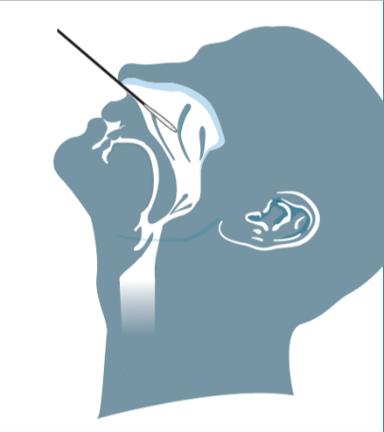
- Tilt your head back.
- Insert the soft tip end of the swab about 2.5cm* (~1 inch or the length of the top knuckle of your thumb to your thumb tip) straight back (not up) into one nostril.
  - Stop when you reach 2.5cm or when you start feeling slight resistance.
- Rotate (turn) the swab slowly against the inside wall of your nose 5 to 10 times. Then leave the swab in place for 2 to 3 seconds.
- Remove the swab from your nose and insert it in your other nostril.
  - Repeat the same steps as above, using the same swab.
*Note: Suggested length applies for adults only. Swab insertion distance is shorter in children.
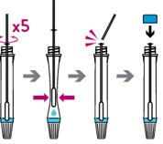
5. Put the swab in the test tube filled with liquid
- Gently insert the soft tip end of the swab into the test tube.
- Swirl the swab in the liquid for 15 seconds and press the soft tip into the inside walls of the tube a few times.
- While leaving the swab inside the tube, pinch the outside of the soft test tube with your fingers to get the remaining liquid out of the soft tip of the swab.
- Throw out the swab in a garbage bag.
  - Alternatively, you can snap the swab handle at the indented breaking point. Throw out the snapped part in the garbage bag, and keep the rest of the swab in the tube.
- Place a blue cap on the test tube and screw it on tightly to avoid leakage.
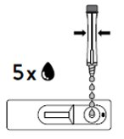
6. Put drops of liquid on the test cartridge
- Gently remove the white nozzle cap at the bottom of the test tube. Be careful not to squeeze the tube while removing the nozzle cap, or the liquid may accidently drip out.
- Once the nozzle cap is removed, hold the tube upright over the round well of the test cartridge.
- Gently squeeze the tube to put 5 drops of liquid into the well (not in the rectangular result window).
  - Make sure that the drops are flowing normally. Bubbles may sometimes clog the opening of the nozzle. If this happens, keep the tube upright and shake it gently to release the bubbles.
- Put the white nozzle cap back on and screw it tightly.
7. Read your result (see the table called How to read your result)
- You must read your result between 15-20 minutes after putting the liquid in the cartridge well.
  - Your result may not be correct if you read your results less than 15 minutes or more than 20 minutes after putting the liquid in the cartridge.
- Make sure you see a visible line next to the C (control) marker.
  - The C line tells you that the right amount of liquid was put in the cartridge well. If there is no visible C line on your cartridge, your test is not working properly. Check the instructions and repeat the test again with a new swab and new test cartridge.
- Check if there is a visible line next to the T (test) marker.
  - If you see a T line, the test is positive, which means you may have COVID-19. Your result is considered preliminary since antigen screening tests may occasionally produce false positive results. You must seek a regular test at an assessment centre or community lab within 48 hours to confirm your result, and self-isolate until the regular test result comes back.
  - If you do not see a T line, the test is negative, which means it is less likely that you have COVID-19 at this time. You can resume your daily activities but be aware that you may still catch COVID-19 and transmit it to others. Continue to follow public health measures such as symptoms checks, appropriate distancing, use of PPE, and handwashing.

How to read your test result
If: | Then:
Only the control line (C) is present. | The result is negative.  If you only see the control line (C) and no test line (T) in the result window, then the test is negative.
The control line (C) and the test line (T) are present. | The result is positive.  If you see the control line (C) and the test line (T) in the result window, then the test is positive. It does not matter which line appeared first.
The control line (C) is clearly present but the test line (T) is faint.  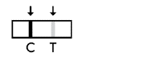 | The result is positive.  If you can see any test line (T), no matter how faint, the result is positive.
The control line (C) is NOT present.  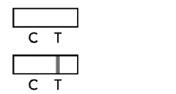 | The test has not worked properly.  If you cannot see the control line (C) within the result window after doing the test, the result is not valid.  Read the test instructions and repeat the test using another swab and test cartridge. You will need to swab your nose again according to the instructions.

8. Wash your hands and throw away the packaging
- Throw away any packaging and waste from the testing process.
- Clean your test area well with a disinfectant.
- Wash your hands with warm water and soap for 20 seconds or use hand sanitizer.
Additional resources
- Public Health Ontario:
- How to Self-Isolate
- You were tested for COVID-19: What you should know
- When to Self-isolate for Household Members

Disclaimer: This document was developed by Ontario Health for training and guidance purposes. The application and use of this document is the responsibility of the user. Ontario Health assumes no liability resulting from any such application or use. Last updated June 23, 2021.

