HYPERTENSION PATIENT SURVEY TEMPLATE

Purpose
This tool is intended to support clinicians who wish to have patient reported information in advance of a virtual visit. This survey can be sent to patients by clinicians or office staff in advance of a visit by selecting one of three options: a standard survey template, OceanMD template, or Microsoft Forms template.

Standard Survey Template
The following content can be copied into your unique surveying program or used as-is by pasting into a new document
Please complete the following questions to the best of your ability.
- How often do you take your blood pressure?
Twice daily
Daily
2 to 3 times weekly
Weekly
Every other week
Monthly
Rarely

- Have you been prescribed medication for hypertension?
Yes
No
Unsure

- If you have been prescribed medication for hypertension, have you been taking it regularly as prescribed?
Yes
No
Sometimes
Other (please explain)

Click or tap here to enter text.

- Do you currently have a Hypertension Canada validated blood pressure monitor available for your use at home? See the list of recommended devices here: https://hypertension.ca/public/recommended-devices
Yes
No

- Please record your average blood pressure over the past 6 days. Click here for the fillable blood pressure readings log from Hypertension Canada.

Systolic (top number) Click or tap here to enter text.

Diastolic (bottom number) Click or tap here to enter text.

OceanMD Survey Template
For users of OceanMD products, this survey can be accessed by following the steps below:

- Login to your Ocean account
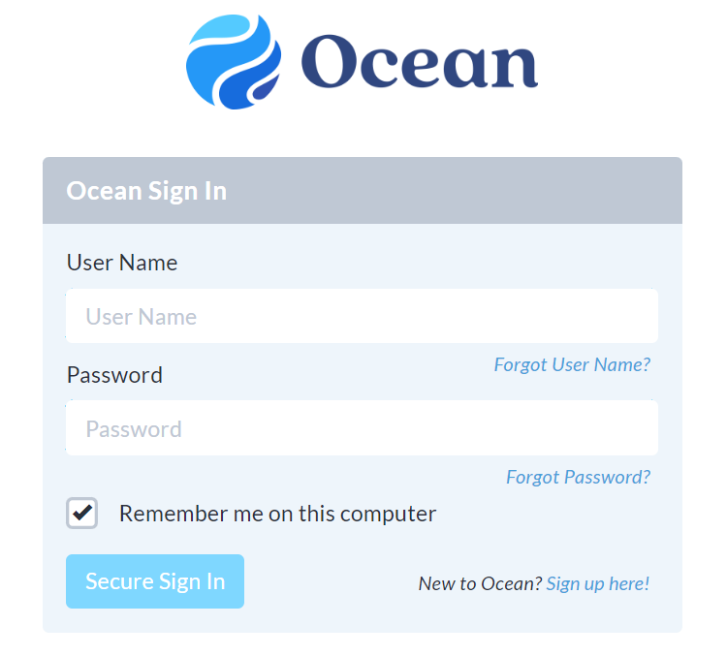

- Navigate to the eForms menu option as illustrated below
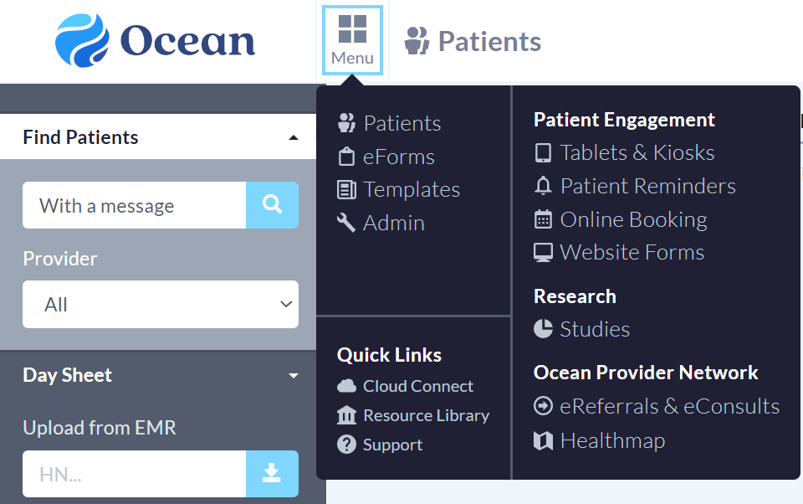

- Type “Hypertension Patient Survey” into the search bar to locate the survey template [note: edits to this survey template can be made when you select the survey]
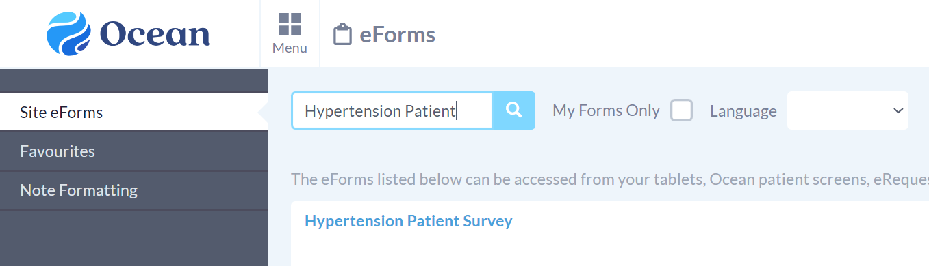

- To email this survey template to patient(s), navigate to the Templates menu option as illustrated below

- Select the desired email template, then scroll down to “add eForm”

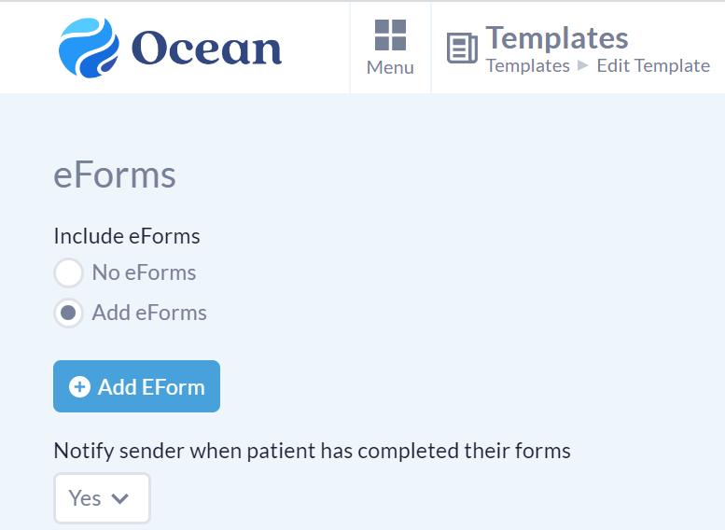

- Type “Hypertension Patient Survey” into the search bar to locate the survey template
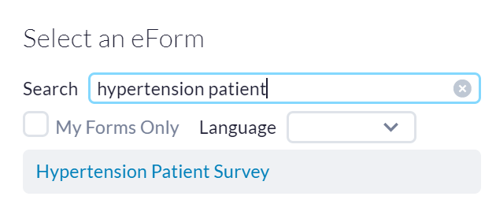
- Click “Save” to add this survey to your email template and follow the prompts to edit/send as desired

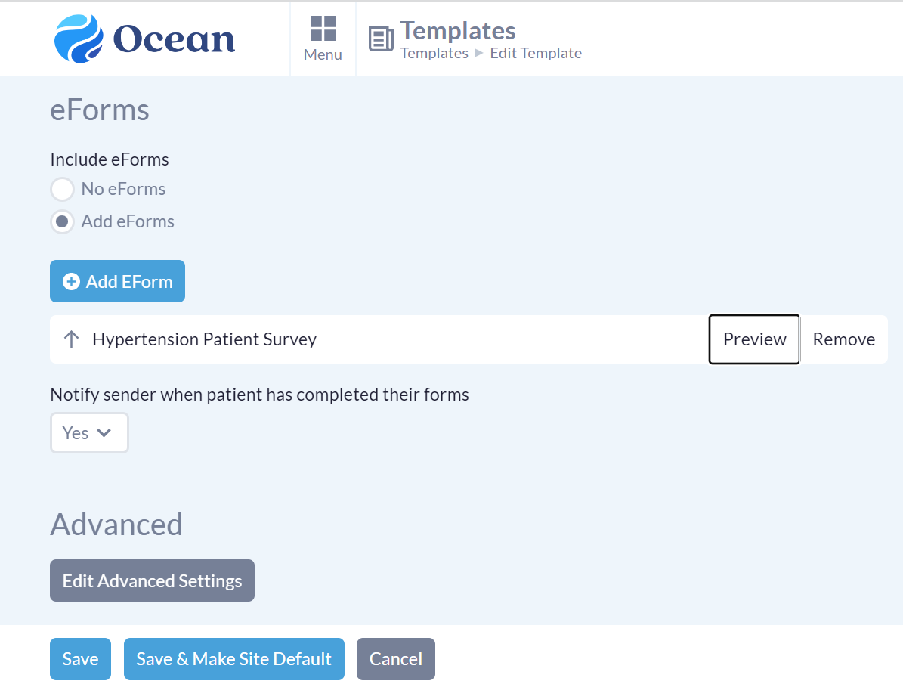

Microsoft Forms Survey Template
For users of Microsoft 365, the following link can be sent to patients by clinicians or office staff by the most appropriate means.
Note: the survey is intended to be duplicated for your own purposes.
